CONSIGNMENTS WANTED
Port Trevorton and Fremont Fire Companies
7th ANNUAL CONSIGNMENT AUCTION
April 25, 2015 – Sale Starts @ 8:30 a.m.
Held at Snyder County Produce: US 11/15 (1 Mile South of Port Trevorton)
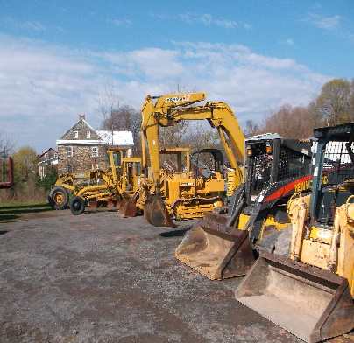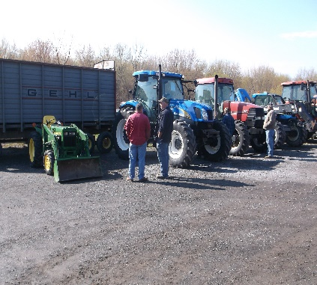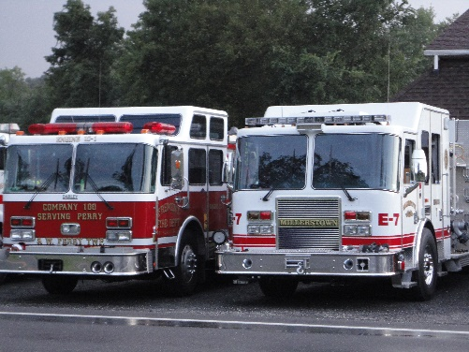
Benefit for Fremont, Port Trevorton Fire Companies &
C.A.M. --- Disaster Response Services
Rapid Response Team of Pennsylvania
View pictures online at www.auctionzip.com Id # 23383
For Large Equipment, trucks, & trailers contact Seth (717) 363-7040
For other information contact Jeff (570)765-8676
Quilt Information Call Sue (570) 539-2061@ 2044 Winding Rd Port Trevorton Pa. 17864
Consignment Wanted, we are looking for the following items for advertising on our sale bill and website. Contact us as soon as possible. Donations are appreciated. Fire Apparatus,pumps, hoses & Misc.
Heavy Equipment, Trucks, Trailers, Farm Machinery,Lawn&Garden
Storage Barns & Sheds; Truck Loads of Hay, Straw, & Fire Wood. Saddles, Tack & Accessories; Buggies, Carriages; Lawn Furniture; Nursery Stock; Hanging Baskets; Bedding Plants; Crafts; Household Goods; New & Used Furniture; Antiques; Collectables; Hand Made Quilts &
All Vehicles and Equipment must have clear titles and UCC.
No Tires, Appliances, TV’s, Computers or Junk.
Live Internet Bidding is available
on Large Equipment only.
Hosted by Equipment Facts
Check out their website for details
@ www.equipmentfacts.com
Equipment facts has over 100,000 International & National registered bidders!!!!
On our 2014 sale we had buyers as far away as Mexico.

Donations & Consignments
Accepted Friday April 24th
8:00 a.m. – 8:00 p.m.
www.auctionzip.com
Reference ID # 23383

Beiler-Campbell Auction Services
J. Meryl Stoltzfus
AU #005403
Jake Yoder
AA #019315

