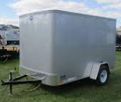
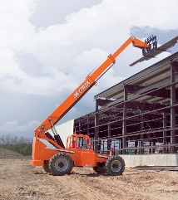
GAP POWER 23rd ANNUAL NO RESERVE AUCTION
Friday February 2 2024 · 11:00AM · Gap, PA (Blizzard Date Monday 2-5-24)
Auction & Vendor Open House at Gap Fire Hall 802 Pequea Avenue Gap PA
NO RESERVE BIDS. NO INTERNET BIDS. NO BUYER PREMIUMS, JUST A GOOD OLD FASHIONED FAST-PACED AUCTION!
Auction Item Preview at 9:00am Friday Feb. 2. Free Pork Sandwiches, Ice Cream etc. at 8:30am
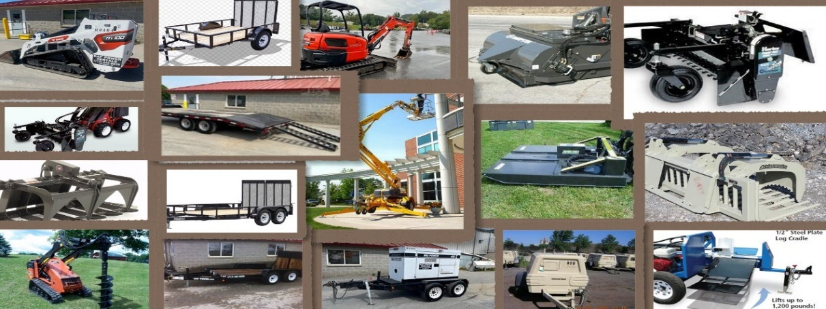
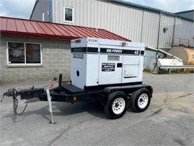

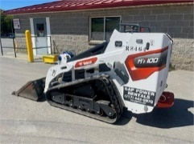

Large Equipment
- Skytrak 10054 telehandler. 110 HP Cummins rebuilt. Stk# R5337 Foam filled tires. 3,900 hours. Year 2011.
- Kubota U35 Mini Excavator 7,500 lbs. 10’ Dig Depth. 2025 hours. Year 2015. Stk# R5325. Includes 24” bucket.
- Bobcat MT100 1,000 lb. capacity stand on loader. 42” wide. With bucket. Year 2022. Stk# R8464 w/ 200 hours.
- Wacker SM100 1,000 lb. capacity stand on loader. 42” wide. With bucket. Year 2022. Stk# R8432 w/ 190 hours.
- Pleasant View Work Platform 10X4' for telehandler. Stk# R7226. Year 2020
Skid Loader Attachments for Stand On Machines. All with standard Ditch Witch / Dingo mount plate, not Bobcat.
- FFC Harley Rake 42” Model D4M. Year 2021. Stk# R7850
- Bradco 42” Grapple Bucket. Model 107036. Year 2022. Stk# 7983
- McMillen Auger Drive Unit. Model X1500. Year 2021. Stk# R7945
Skid Loader Attachments for Standard Size Loaders
- Blue Diamond 72” pick up type sweeper. Model 116515 Year 2017. Stk# R5993
- Blue Diamond brush mower 72”. Model 103020. Year 2021. Stk# R7885
- FFC Harley Rake 72” Model M6M-0022. Year 2020. Stk# R7202
- Steinsammler 84” grapple bucket. Model 830GR. Year 2019. Stk# R6486
Towable
- Bil Jax 35 foot man lift. Model 3522-A. Year 2017. In motion hours 336. Stk# R5655
- Mighty Ox Blue wood splitter with lifting tray. 2021 year. Stk# 7803
- Multiquip DCA1645 tow behind generator. 45KW 45,000 watt. 2007 Year. Stk# R4397. 16,500 hours
- IR 185 Air Compressor. 185 CFM. Diesel. Stk# R4473. Year 2013. 5,800 hours
- Air Spade Model HT106 for 185 compressor for soft excavation. Stk# R5996. Year 2017
Trailers
- United 6’x10’ enclosed trailer. Stk# R7091. Barn doors, no ramp. Year 2019
- Centerville low profile scissors lift trailer w/ ramps. Stk# R5500. 2016 year.
- Belmont Deck Over Trailer 8.5x20' flip-up tail. Stk# R7357. Year 2021. 10,000 GVW
- Belmont 6x14’ landscape trailer. With full ramps and side rail. Year 2020. Stk# R7297. 7,000 GVW
- Belmont 6x10’ utility trailer with full ramp and side rail. Year 2016. Stk# R6476. 3,000 GVW
25-30 rental/new/used/Stihl machines. Saws, blowers, trimmers, cutoffs, hedge trimmers.
R8350 10 foot Sumner beam lift. 20’ Sumner Lift R5980. R8553 Honda 2200 generator. R7680 Jair 6.5HP air compressor. R7149 ventilation blower. 30 lb demo hammer HM1307CB. R7657 Bosch hack hammer. R8150 Bartell 36” trowler. (2) R6742. R6745 LGR7000 dehumidifier 29GPD. R5560 Bosch hammer drill. 4688 30A electric Heater. R6104 L B White propane heater 170K btu. R7418 Bluebird sod cutter. R4838 27 caliber gun. R5933 Max PRJC160 battery rebar cutter. R7821 14” elec conc saw. R6806 Dewalt DCS690B 60v conc saw.
ABOVE IS A PARTIAL LIST. ADDING BOX LOTS, CLOSE OUTS, USED & NEW POWER TOOLS & HAND TOOLS.
Item by item auction day list with lot numbers will be available approx. 1-30-24
AUCTION DAY CATALOG W/ LOT NUMBERS AT AUCTION. ALSO AVAILABLE ON WEBSITE & IN STORE A FEW DAYS BEFORE AUCTION.
25-30 rental/new/used/Stihl machines. Saws, blowers, trimmers, cutoffs, hedge trimmers.
MANY STIHL MODELS TO CHOOSE FROM…STIHL 50/50 C.A.R.E. FUNDRAISER....C.A.R.E. WORKING IN GOLDEN MEADOW, LOUISIANA & WILL BE SENDING approx. 35 VOLUNTEERS FOR 1 WEEK PERIODS DURING 2024
C.A.RE. Benefits. 50% of Stihl Auction will be donated to C.A.R.E. UNRESERVED AUCTION, EVERYTHING SELLS TO THE HIGH BIDDER. Auctioneer: Meryl Stoltzfus, Beiler Campbell Auction Services License # AU005403 (717)629-6036.
Gap Power Rentals 717 442 8970 Terms cash, credit card or local check day of auction. Gap Power Rentals · 5399 Lincoln Hwy · Gap, PA 17527

